12. DEMONSTRATE CYBER EVASION TECHNIQUES
DATE: 08/04/2026
Aim:To learn cyber evasion techniques and put them to the test against two IDS.
Procedure:
- Log into TryHackMe and open the Intrusion Detection room.
- Study the basics of Intrusion Detection Systems (IDS) and their role in security.
- Understand common detection methods such as signature-based and anomaly-based detection.
- Learn cyber evasion techniques used to bypass IDS.
- Analyze how different IDS respond to various attack patterns.
- Perform tasks to test evasion techniques against the IDS.
- Review results and confirm completion.
Tasks:
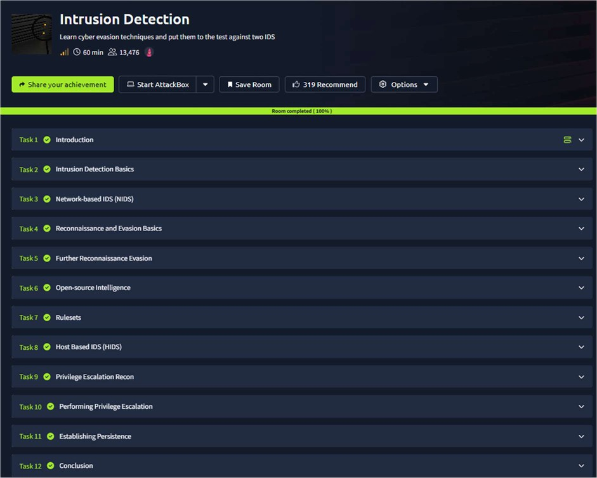

TASK 1 - Introduction
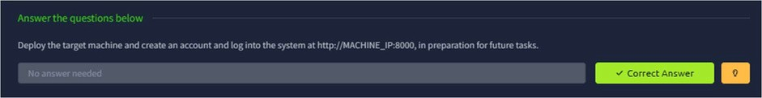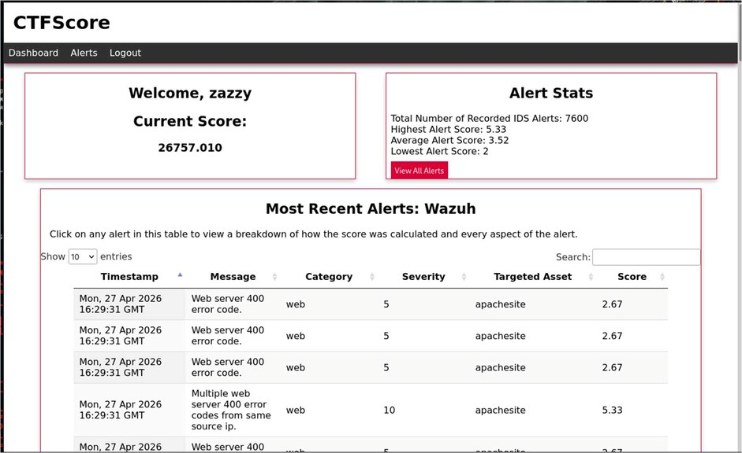
TASK 2 – Intrusion Detection Basics
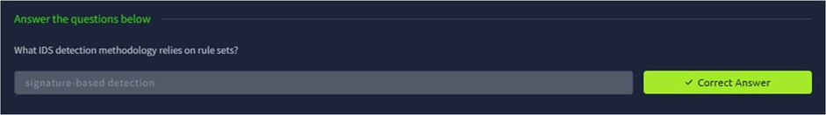
TASK 3 -Network based IDS (NIDS)
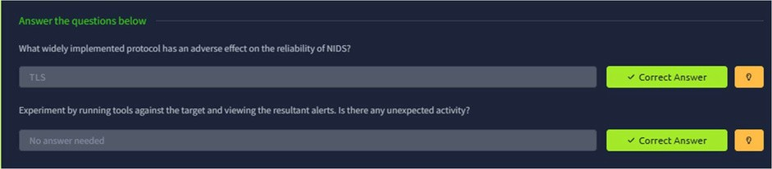

TASK 4 – Reconnaissance and Evasion Basics
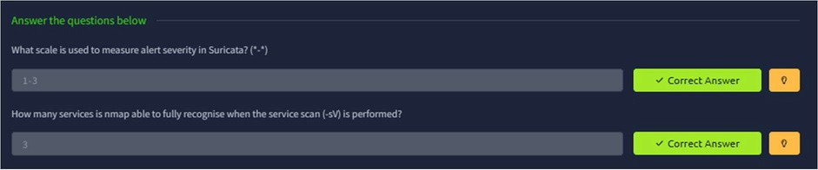
TASK 5 – Further Reconnaissance Evasion
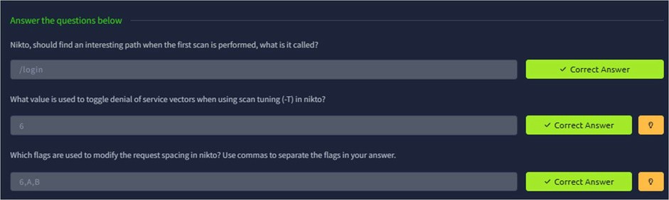
TASK 6 – Open Source Intelligence
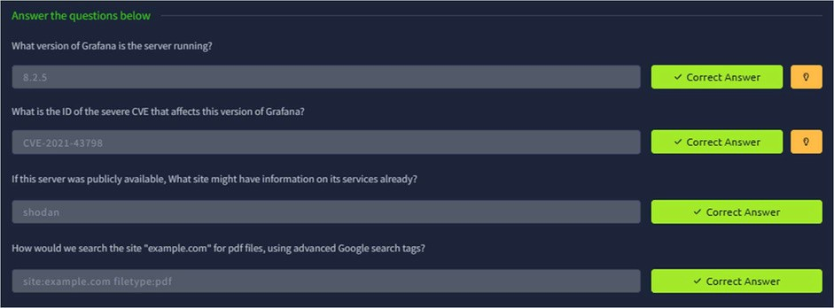
TASK 7 - Rulesets
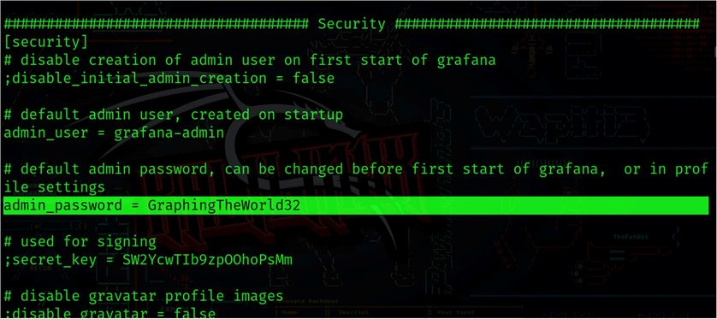
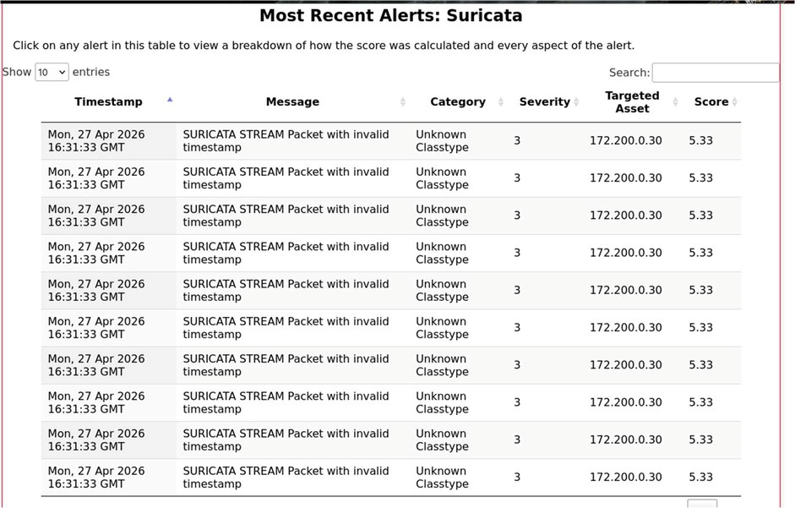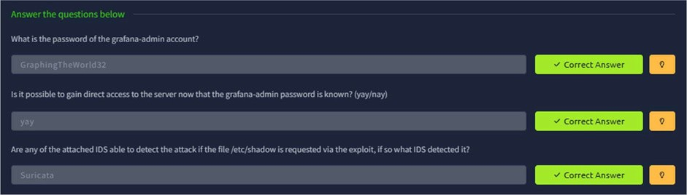
TASK 7 – Host Based IDS (HIDS)
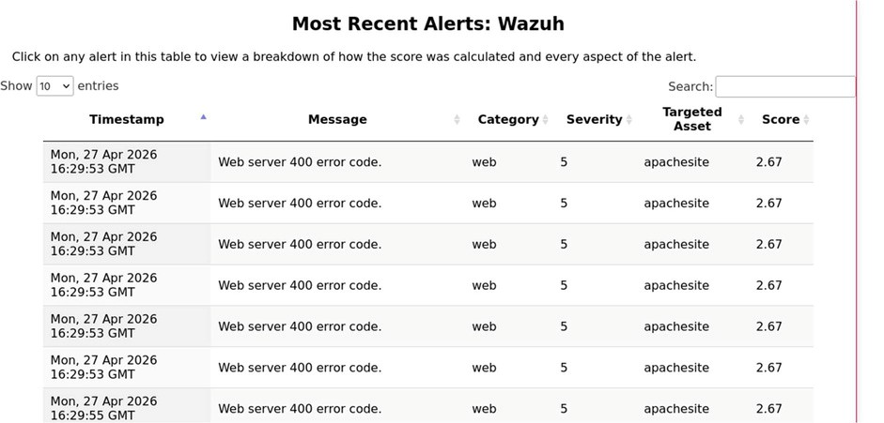

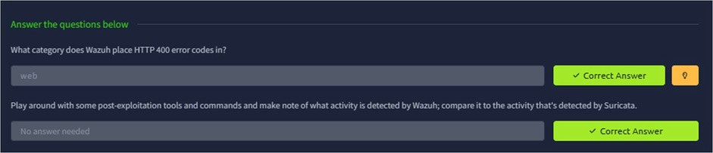
TASK 9 – Privilege Escalation Recon
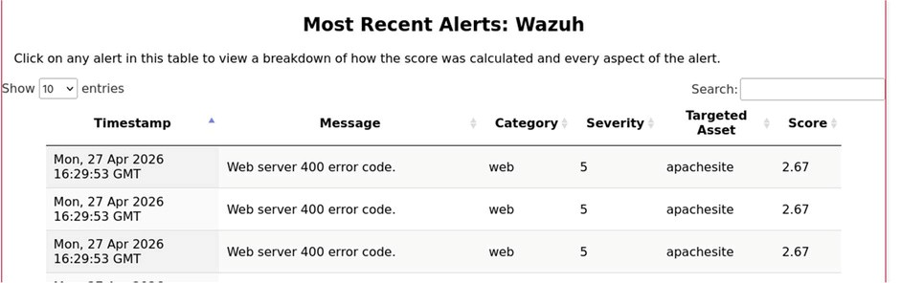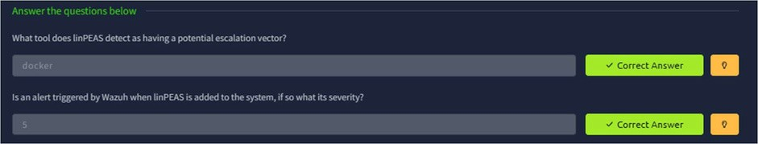
TASK 10 – Performing Privilege Escalation

TASK 11 – Establishing Persistence
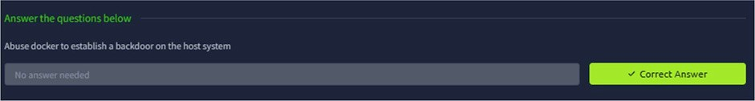

TASK 12 - Conclusion

Result:
Thus the TryHackMe room “Intrusion Detection” was completed successfully.

